3. Types of Cloud Services or Services Delivery model

The cloud services provided are:

1. Software as a Service.
2. Platform as a Service.
3. Infrastructure as a Service.

We’ll discuss this by using an example of transportation:

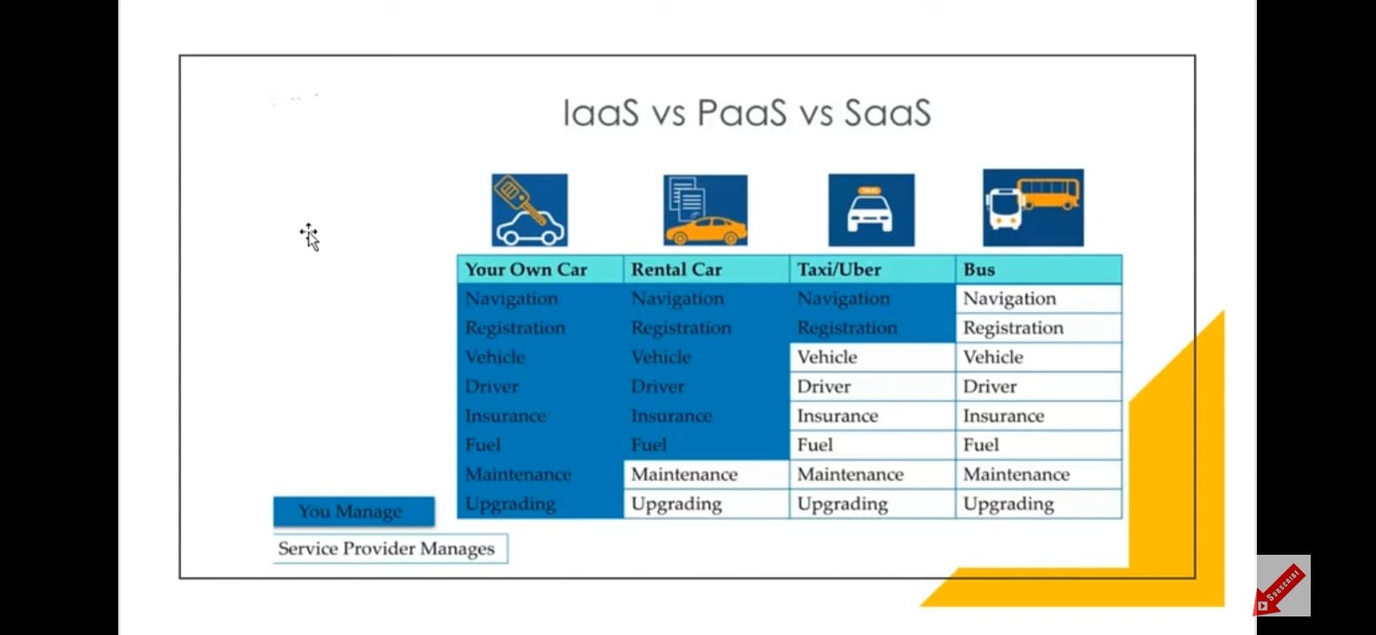

Here, the following table represents:

Your own car: Navigation, registration, Vehicle, driver, insurance, Fuel maintenance, upgrading all comes as the services which we have to take care of while owning a car.

Rental Car: Navigation, registration, Vehicle, driver, insurance, Fuel, all comes as the services which we have to take care of while renting a car whereas maintenance and upgrading is done by the owner and not the temporary user.

Taxi/Uber: Navigation, registration comes as the services which we have to take care of while ordering a taxi or an Uber. Vehicle, driver, insurance, Fuel maintenance, upgrading is all done by the taxi service provider or the company.

Bus: Navigation, registration, Vehicle, driver, insurance, Fuel maintenance, upgrading all comes as the services which the bus service providers take care for transportation. We don’t have access to any other service than the one which we are provided.

In the On-Premises, IAAS, PAAS, and SAAS:

The above example relates to the services provided in the transportation System and the Cloud Services.

* Your Own Car relates to On-premises.
* Rental car relates to IAAS.
* Taxi/Uber relates to PAAS.
* Bus relates to SAAS.

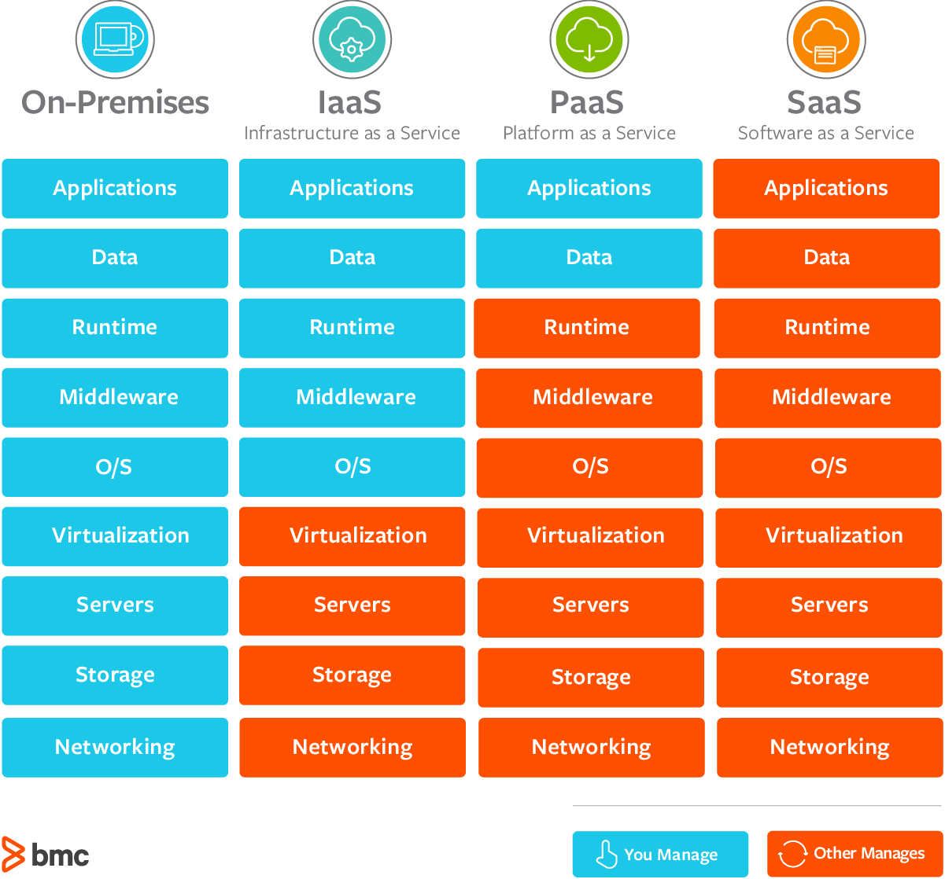

Here, the data in the two tables is closely related to the services provided by each other.

We’ve been using some Cloud Services via these applications:

1. Gmail:

* Email cloud service.
* Pay for only your emails stored (no infrastructures, etc.)

1. Dropbox:

* Cloud Storage Service.
* Originally built on AWS.

1. Netflix:

* Built on AWS.
* Videos on demand.